**DAILY ONLINE ACTIVITIES SUMMARY**

|  |  |  |  |  |  |  |  |  |
| --- | --- | --- | --- | --- | --- | --- | --- | --- |
| **Date:** | **31/05/2020** | | | | | **Name:** | **PRATIBHA SHEETI** | |
| **Sem & Sec** | **IV sem & B section** | | | | | **USN:** | **4AL18CS062** | |
| **Online Test Summary** | | | | | | | | |
| **Subject** | | **-** | | | | | | |
| **Max. Marks** | | **30** | | **Score** | | | **-** | |
| **Certification Course Summary** | | | | | | | | |
| **Course** | **Java learning** | | | | | | | |
| **Certificate Provider** | | | **Greatlearning academy** | | **Duration** | | | **2.5 hours** |
| **Coding Challenges** | | | | | | | | |
| **Problem Statement1:** Write a Java program to calculate nPr. | | | | | | | | |
| **Status: Executed** | | | | | | | | |
| **Uploaded the report in Github** | | | | | **YES** | | | |
| **If yes Repository** | | | | | **https://github.com/pratibhashetty-123/Lockdown-coding-java** | | | |
| **Uploaded the report in slack** | | | | | **YES** | | | |

Online Test Summary: No internals conducted today.

Online Certification Course Summary:

Name of the course : java learning

In today's session . I learnt downloading and installing the Anacoda in my system and I completed 2 modules in java and also learnt java IDE

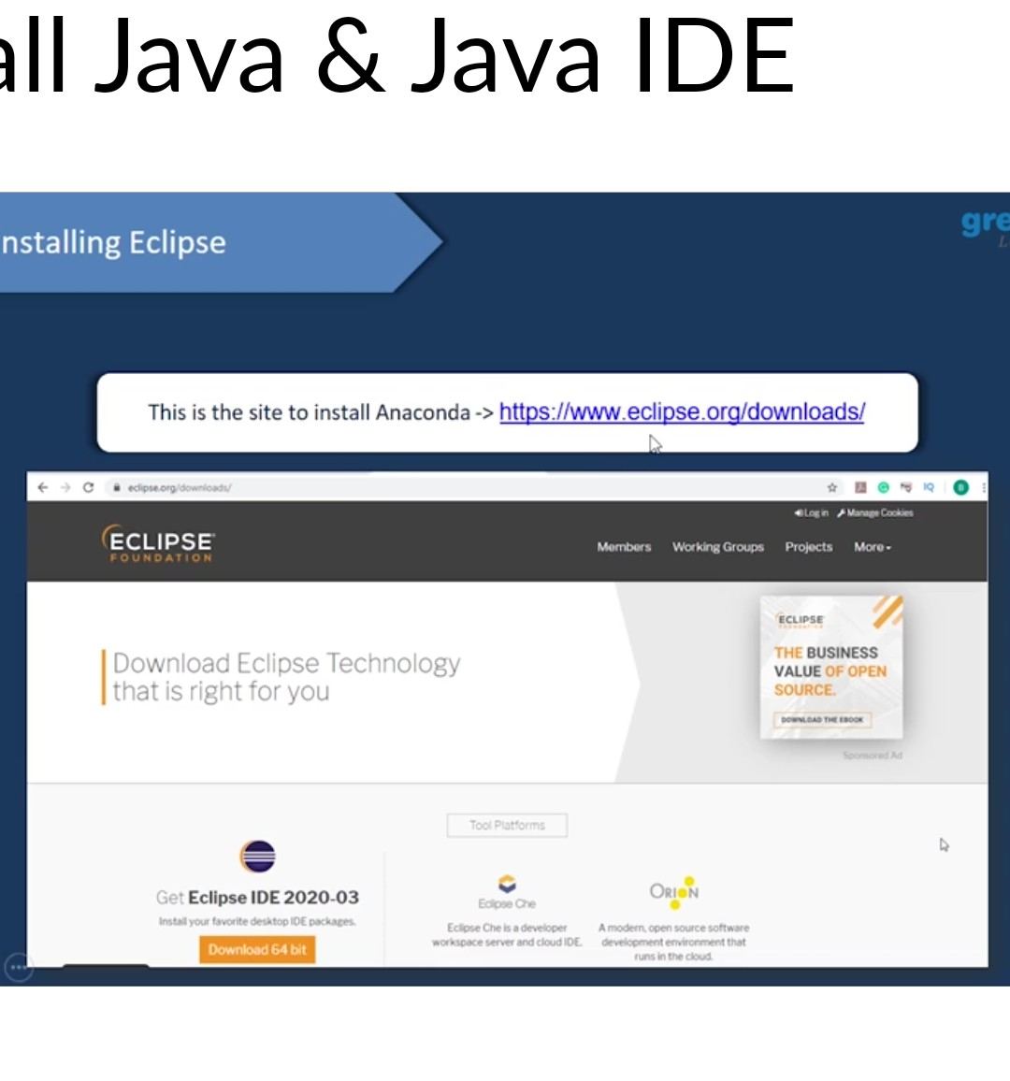

These are the Snap shots of today’s sessions.

Online Coding Summary: **Today I had received one program from prof. Shilpa CSE Dept. The program is mentioned above in the coding challenges(pg.01). I have also uploaded it to my Github repository.**

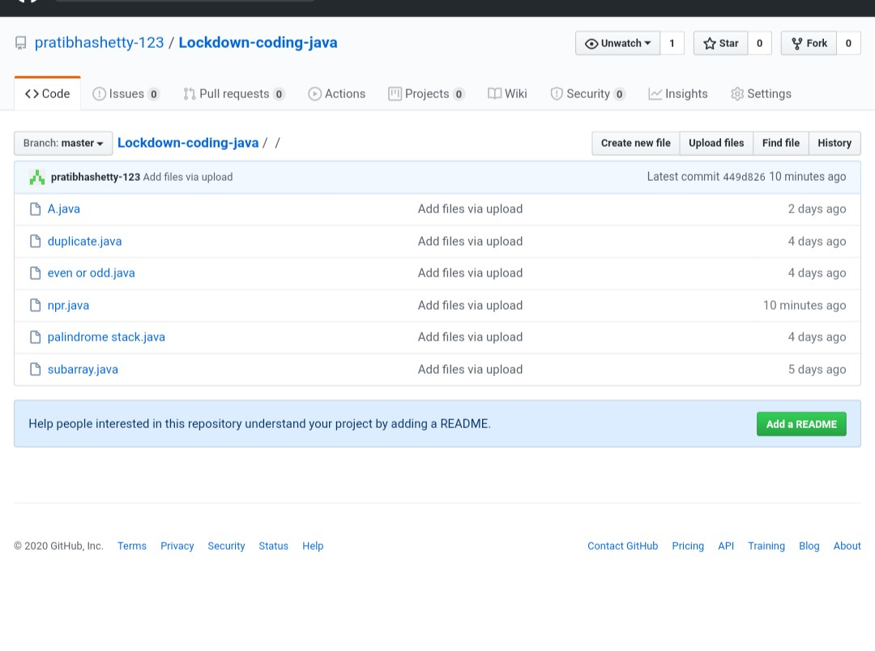

**This is the snap shot of my Github repository** were I have uploaded the code. File name is npr.java